SynapseOS
AI-Powered Enterprise Financial Intelligence & Decision Intelligence Platform
Capstone Project Report
Project Category: Data Science, Machine Learning, Artificial Intelligence, Generative AI, MLOps
Technology Stack: FastAPI, Next.js, PostgreSQL, Neo4j, Qdrant, LangGraph, MLflow, Docker
Executive Summary
Organizations today generate significant volumes of structured and unstructured information through financial transactions, operational reports, supplier documentation, compliance records, and business performance metrics. Despite this abundance of data, decision-making remains largely reactive due to fragmented information systems and the lack of intelligent analytical capabilities.
Traditional Business Intelligence platforms primarily focus on descriptive analytics, enabling organizations to understand historical performance. However, modern enterprises require systems capable of predictive, prescriptive, and contextual intelligence.
SynapseOS is proposed as an AI-Powered Enterprise Financial Intelligence Platform that integrates Machine Learning, Retrieval-Augmented Generation (RAG), GraphRAG, Agentic AI, Model Context Protocol (MCP), and Digital Twin Simulation into a unified decision intelligence system.
The platform enables organizations to:
- Analyze financial performance
- Forecast future business outcomes
- Detect operational risks
- Retrieve insights from enterprise documents
- Understand complex business relationships
- Simulate strategic decisions before implementation
The objective is to transform enterprise data into actionable intelligence through explainable and production-oriented AI systems.
1. Introduction
1.1 Background
Organizations increasingly rely on digital systems to manage financial operations, customer interactions, supply chains, and business reporting. These systems continuously generate valuable data that can be leveraged to support strategic decision-making.
Despite widespread adoption of Business Intelligence tools, many organizations still face challenges including:
- Fragmented data sources
- Delayed insights
- Manual report generation
- Limited predictive capabilities
- Lack of contextual understanding
As Artificial Intelligence technologies mature, organizations are seeking platforms capable of combining predictive analytics with knowledge reasoning and scenario simulation.
1.2 Motivation
Current enterprise analytics platforms typically answer:
"What happened?"
However, business leaders increasingly require answers to:
- Why did it happen?
- What will happen next?
- What factors are influencing outcomes?
- What should be done next?
- What happens if a specific decision is implemented?
SynapseOS is designed to address these requirements through a unified AI-driven decision intelligence architecture.
1.3 Project Vision
To develop a production-oriented enterprise intelligence platform that combines financial analytics, machine learning, enterprise knowledge retrieval, multi-agent reasoning, and simulation-driven decision support.

2. Problem Statement
Organizations generate substantial amounts of data from financial transactions, operational activities, business documents, and enterprise systems. However, extracting actionable intelligence from this information remains challenging.
Existing solutions often suffer from:
- Data silos
- Static reporting
- Lack of explainability
- Limited predictive capabilities
- Absence of decision simulation
As a result, organizations spend significant time performing manual analysis while critical decisions continue to rely heavily on intuition.
There is a need for an integrated platform capable of combining analytics, knowledge retrieval, forecasting, risk detection, and strategic simulation within a single system.

3. Project Objectives
The primary objectives of SynapseOS are:
Objective 1
Develop a multi-tenant enterprise intelligence platform capable of supporting multiple organizations securely.
Objective 2
Implement forecasting models for revenue, profit, expenses, and business performance metrics.
Objective 3
Develop anomaly detection mechanisms to identify unusual financial activities and operational risks.
Objective 4
Implement Retrieval-Augmented Generation (RAG) for enterprise document intelligence.
Objective 5
Implement GraphRAG for relationship-based reasoning across enterprise entities.
Objective 6
Develop a Multi-Agent AI framework capable of collaborative problem solving.
Objective 7
Implement a Digital Twin simulation environment for strategic decision analysis.
Objective 8
Adopt modern MLOps, monitoring, and deployment practices suitable for production environments.

4. Scope of the Project
Included Features
Financial Analytics
- Revenue analysis
- Profitability analysis
- Expense analysis
- KPI monitoring
Forecasting
- Revenue forecasting
- Profit forecasting
- Expense forecasting
Risk Detection
- Financial anomaly detection
- Operational risk identification
Knowledge Intelligence
- Enterprise document search
- Question answering
- Context retrieval
Relationship Intelligence
- Supplier dependency analysis
- Business impact analysis
- Root cause exploration
Agentic AI
- Multi-agent collaboration
- Tool orchestration
- Recommendation generation
Digital Twin
- Business simulation
- Scenario planning
- Strategic impact forecasting
Out of Scope
The following features are intentionally excluded from the initial release:
- Custom LLM training
- Enterprise ERP integrations
- Mobile applications
- Real-time voice assistants
- Advanced reinforcement learning
- Blockchain systems

5. Target Audience
SynapseOS is designed for organizations that rely on data-driven decision making.
Executive Leadership
- Chief Executive Officers (CEOs)
- Chief Financial Officers (CFOs)
- Chief Operating Officers (COOs)
- Key Requirements: Strategic forecasting, Business simulations, Decision support
Business Analysts
- Key Requirements: Trend analysis, KPI monitoring, Enterprise search
Risk and Compliance Teams
- Key Requirements: Anomaly detection, Audit support, Risk assessment
Operations Managers
- Key Requirements: Cost optimization, Supplier analysis, Resource planning

6. Business Value Proposition
Traditional analytics solutions focus on descriptive reporting. SynapseOS extends analytics through:
- Descriptive Intelligence: Understanding historical performance.
- Predictive Intelligence: Forecasting future outcomes.
- Knowledge Intelligence: Extracting information from enterprise documents.
- Relationship Intelligence: Understanding interconnected business entities.
- Decision Intelligence: Evaluating future strategic decisions.
Expected Benefits
Operational Benefits
- Faster decision making
- Reduced manual analysis
- Improved information accessibility
Financial Benefits
- Improved forecasting accuracy
- Reduced operational risks
- Better resource allocation
Strategic Benefits
- Scenario planning
- Decision simulation
- Enhanced organizational intelligence

7. Competitive Analysis
Capability | Traditional BI | SynapseOS
Dashboards | Yes | Yes
Forecasting | Limited | Yes
Enterprise Search | No | Yes
RAG | No | Yes
GraphRAG | No | Yes
Agentic AI | No | Yes
Digital Twin Simulation | No | Yes
Decision Intelligence | Limited | Yes
8. Innovation & Novel Contributions
The novelty of SynapseOS lies in the integration of multiple advanced AI capabilities within a unified enterprise platform.
GraphRAG for Financial Intelligence
Relationship-based reasoning across business entities.
Agentic Decision Intelligence
Collaborative AI agents specializing in financial, risk, forecasting, and knowledge domains.
Digital Twin Simulation
Business scenario simulation for decision support.
Unified Enterprise Intelligence
Combining forecasting, RAG, GraphRAG, Agentic AI, and simulation within a single architecture.

9. System Architecture
9.1 Architectural Overview
SynapseOS follows a cloud-native microservices architecture designed to support scalability, maintainability, and independent service deployment.
The architecture is organized into six primary layers:
- Presentation Layer: Responsible for user interaction and visualization.
- Application Layer: Hosts business services and APIs.
- Intelligence Layer: Contains AI, Machine Learning, and Agentic AI components.
- MCP Layer: Provides standardized access to tools and enterprise resources.
- Data Layer: Stores transactional, vector, graph, and caching data.
- Operations Layer: Provides monitoring, logging, deployment, and observability capabilities.
9.2 High-Level System Architecture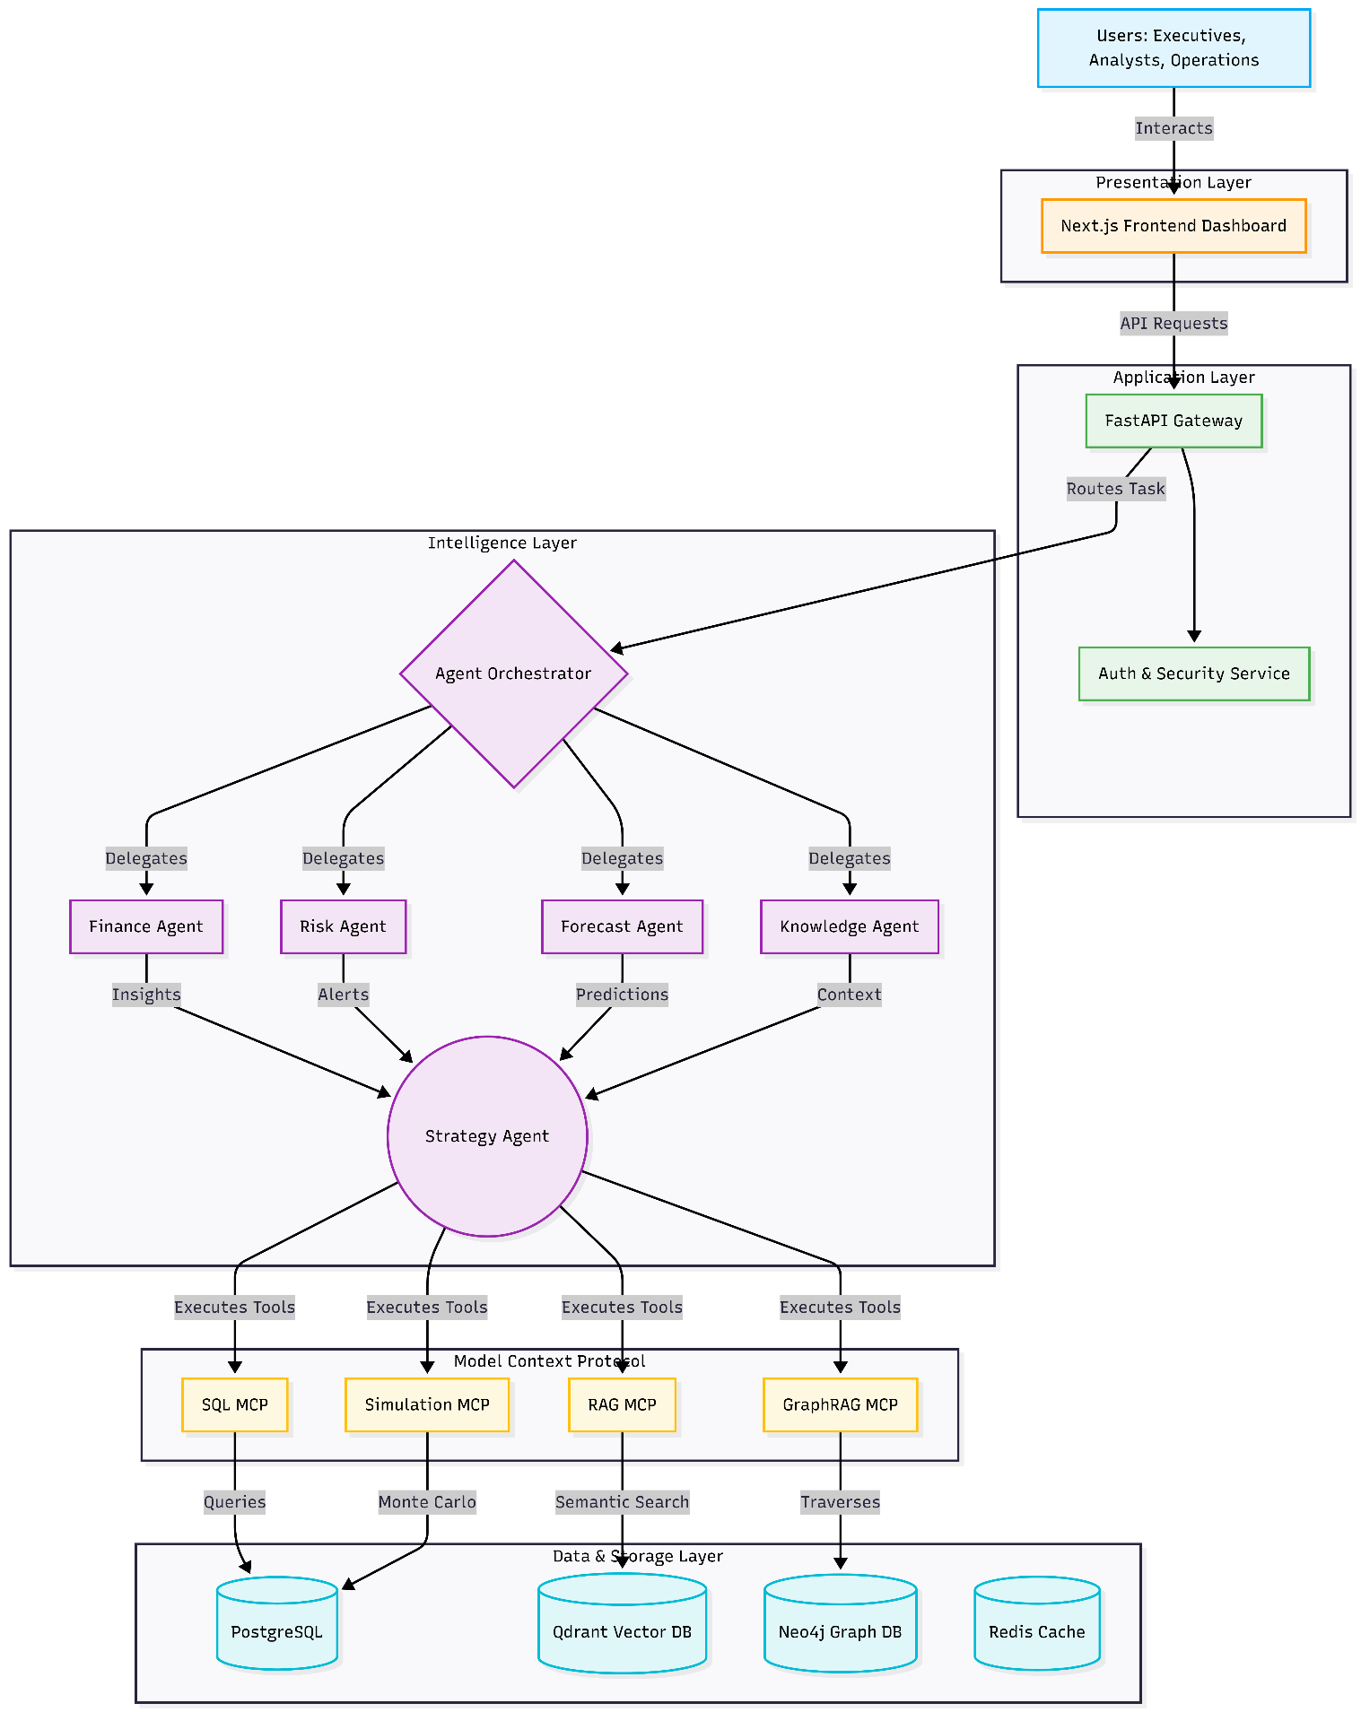
9.3 Architectural Principles
The architecture is guided by the following principles:
- Scalability: Each service can scale independently.
- Separation of Concerns: Business logic is isolated into dedicated services.
- Explainability: All AI-generated outputs should be traceable and explainable.
- Extensibility: New agents and MCP tools can be introduced without major architectural modifications.
- Observability: System behavior must be measurable through logs, metrics, and traces.

10. Technology Architecture
Frontend Layer
- Framework: Next.js
- Language: TypeScript
- Styling: TailwindCSS
- Responsibilities: Dashboard Rendering, Authentication, Visualization, User Interaction
Backend Layer
- Framework: FastAPI
- Language: Python
- Package Manager: uv
- Responsibilities: Business Logic, API Management, Service Orchestration, AI Integration

11. Microservices Architecture
SynapseOS adopts a modular microservices architecture.
Authentication Service
- Responsibilities: User Registration, User Authentication, Role Management, Tenant Management
- Outputs: JWT Tokens, Access Control Decisions
Forecast Service
- Responsibilities: Revenue Forecasting, Profit Forecasting, Cashflow Forecasting
- Outputs: Predictions, Confidence Scores
Risk Service
- Responsibilities: Financial Risk Detection, Anomaly Detection
- Outputs: Risk Scores, Alert Generation
RAG Service
- Responsibilities: Document Processing, Embedding Generation, Information Retrieval
- Outputs: Retrieved Context, Source References
GraphRAG Service
- Responsibilities: Graph Traversal, Relationship Discovery, Context Expansion
- Outputs: Relationship Intelligence, Root Cause Explanations
Agent Service
- Responsibilities: Agent Coordination, Task Routing, Recommendation Generation
- Outputs: Business Insights, Recommendations
Simulation Service
- Responsibilities: Digital Twin Execution, Scenario Analysis, Strategic Simulations
- Outputs: Scenario Results, Risk Assessments

12. Data Architecture
SynapseOS adopts a polyglot persistence strategy. Different databases are selected according to workload requirements.
PostgreSQL
- Purpose: Primary transactional database.
- Stores: Users, Tenants, Transactions, Forecasts, Alerts, Simulations.
- Justification: Provides ACID compliance, Reliability, Strong analytical support.
Qdrant
- Purpose: Vector storage for semantic search.
- Stores: Embeddings, Document Chunks.
- Justification: Provides Fast similarity search, Metadata filtering, Open-source deployment.
Neo4j
- Purpose: Relationship intelligence.
- Stores: Suppliers, Products, Customers, Risks, Business Dependencies.
- Justification: Provides Native graph traversal, Multi-hop reasoning, GraphRAG support.
Redis
- Purpose: High-speed caching and temporary state management.
- Stores: Sessions, Agent State, Frequently Accessed Queries.
- Justification: Provides sub-millisecond access times.

13. Data Flow Architecture
Financial Analytics Workflow
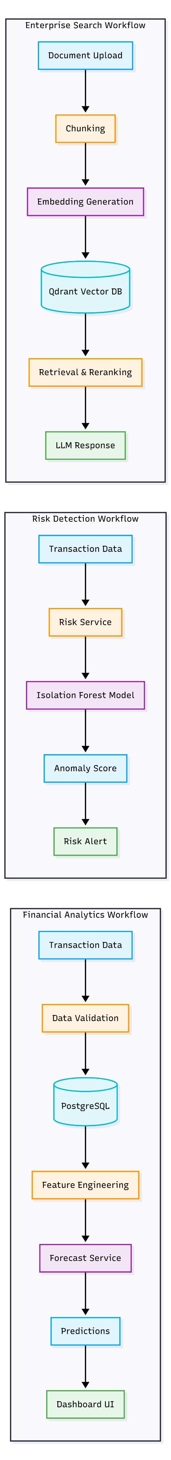
Risk Detection Workflow
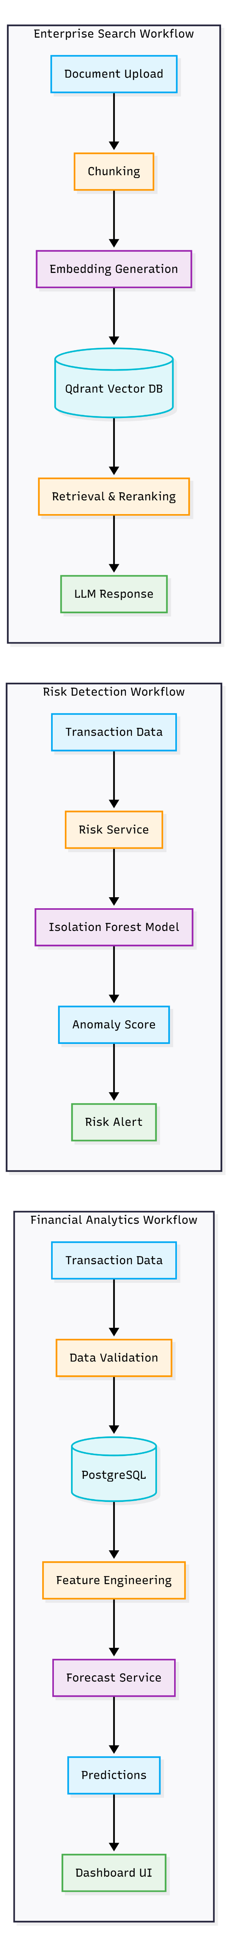

Enterprise Search Workflow
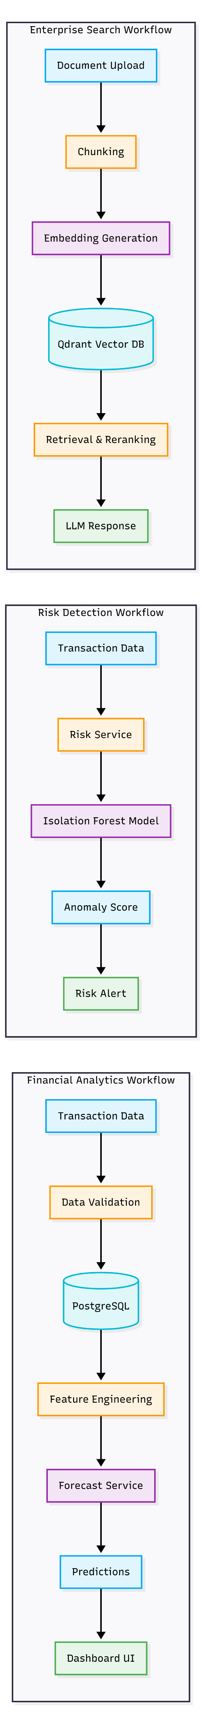
14. Real-Time Event Architecture
SynapseOS incorporates event-driven communication for real-time processing.
Event Flow
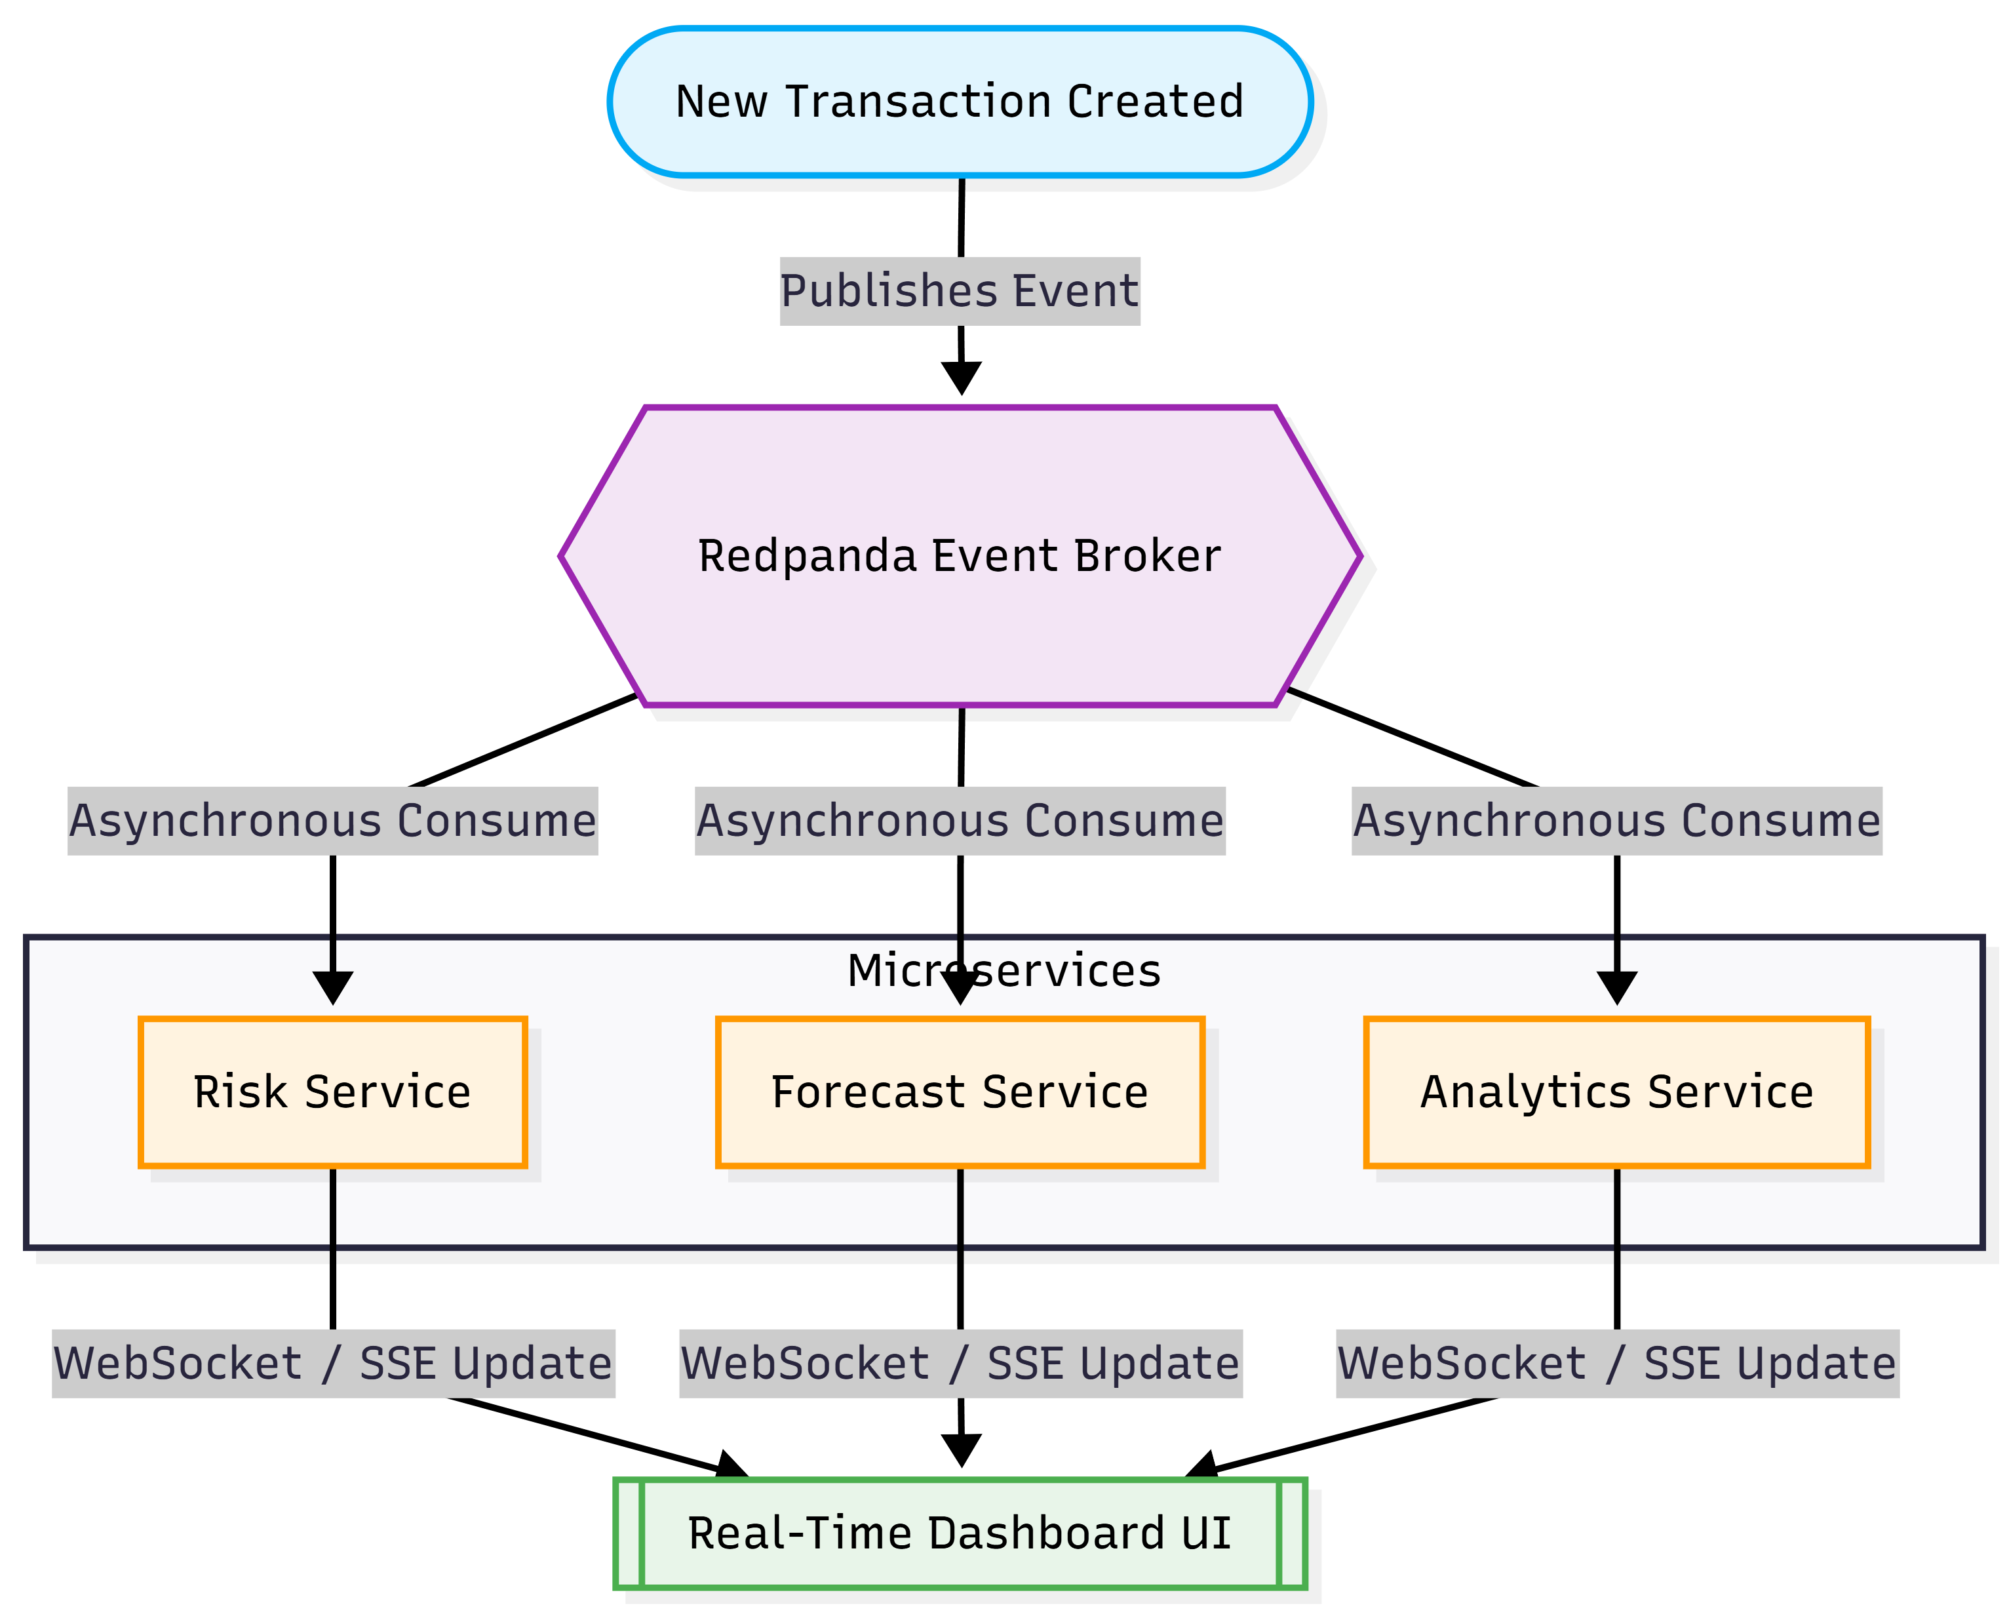Benefits
- Decoupling: Services communicate asynchronously.
- Scalability: Consumers can scale independently.
- Reliability: Events remain available for processing.
- Real-Time Insights: Immediate updates across the platform.

15. Deployment Architecture
Development Environment
- Docker Compose
- Components: Frontend, Backend Services, PostgreSQL, Neo4j, Qdrant, Redis, MLflow
Production Environment
Containerized deployment.
- Infrastructure Components:
Load Balancer ➔ Frontend ➔ API Gateway ➔ Microservices ➔ Data Layer
Future Production Deployment
- Kubernetes: Provides Auto-scaling, Service discovery, Fault tolerance.
- Cloud Deployment: Potential providers include AWS, Azure, Google Cloud.

16. Design Decisions & Technical Justification
Why FastAPI?
- High performance
- Native async support
- Automatic API documentation
- Strong Python ecosystem integration
Why LangGraph?
- State management
- Multi-agent workflows
- Agent orchestration
Why Qdrant?
- High-performance vector retrieval
- Metadata support
- Production-ready deployment
Why Neo4j?
- Native graph modeling
- Relationship reasoning
- GraphRAG implementation
Why Docker?
- Environment consistency
- Deployment simplicity
- Industry-standard containerization
Why MLflow?
- Experiment tracking
- Model versioning
- Reproducibility

17. Risks and Limitations
Data Quality
Forecast accuracy depends heavily on historical data quality.
AI Hallucinations
Generative models may produce incorrect information.
- Mitigation: RAG, Source grounding, Retrieval verification.
Simulation Assumptions
Digital Twin outputs depend on assumptions derived from historical data. Results should be treated as decision support rather than guarantees.
Infrastructure Complexity
Microservice architectures introduce operational complexity.
- Mitigation: Containerization, Monitoring, Documentation.
18. Artificial Intelligence & Intelligence Layer
The Intelligence Layer represents the core innovation of SynapseOS. Unlike traditional Business Intelligence platforms that focus primarily on reporting and visualization, SynapseOS combines predictive analytics, knowledge retrieval, relationship reasoning, and decision simulation to create an Enterprise Intelligence Platform.
The Intelligence Layer consists of:
- Machine Learning Models
- Retrieval-Augmented Generation (RAG)
- GraphRAG
- Multi-Agent AI
- Model Context Protocol (MCP)
- Digital Twin Simulation
18.1 Intelligence Layer Architecture
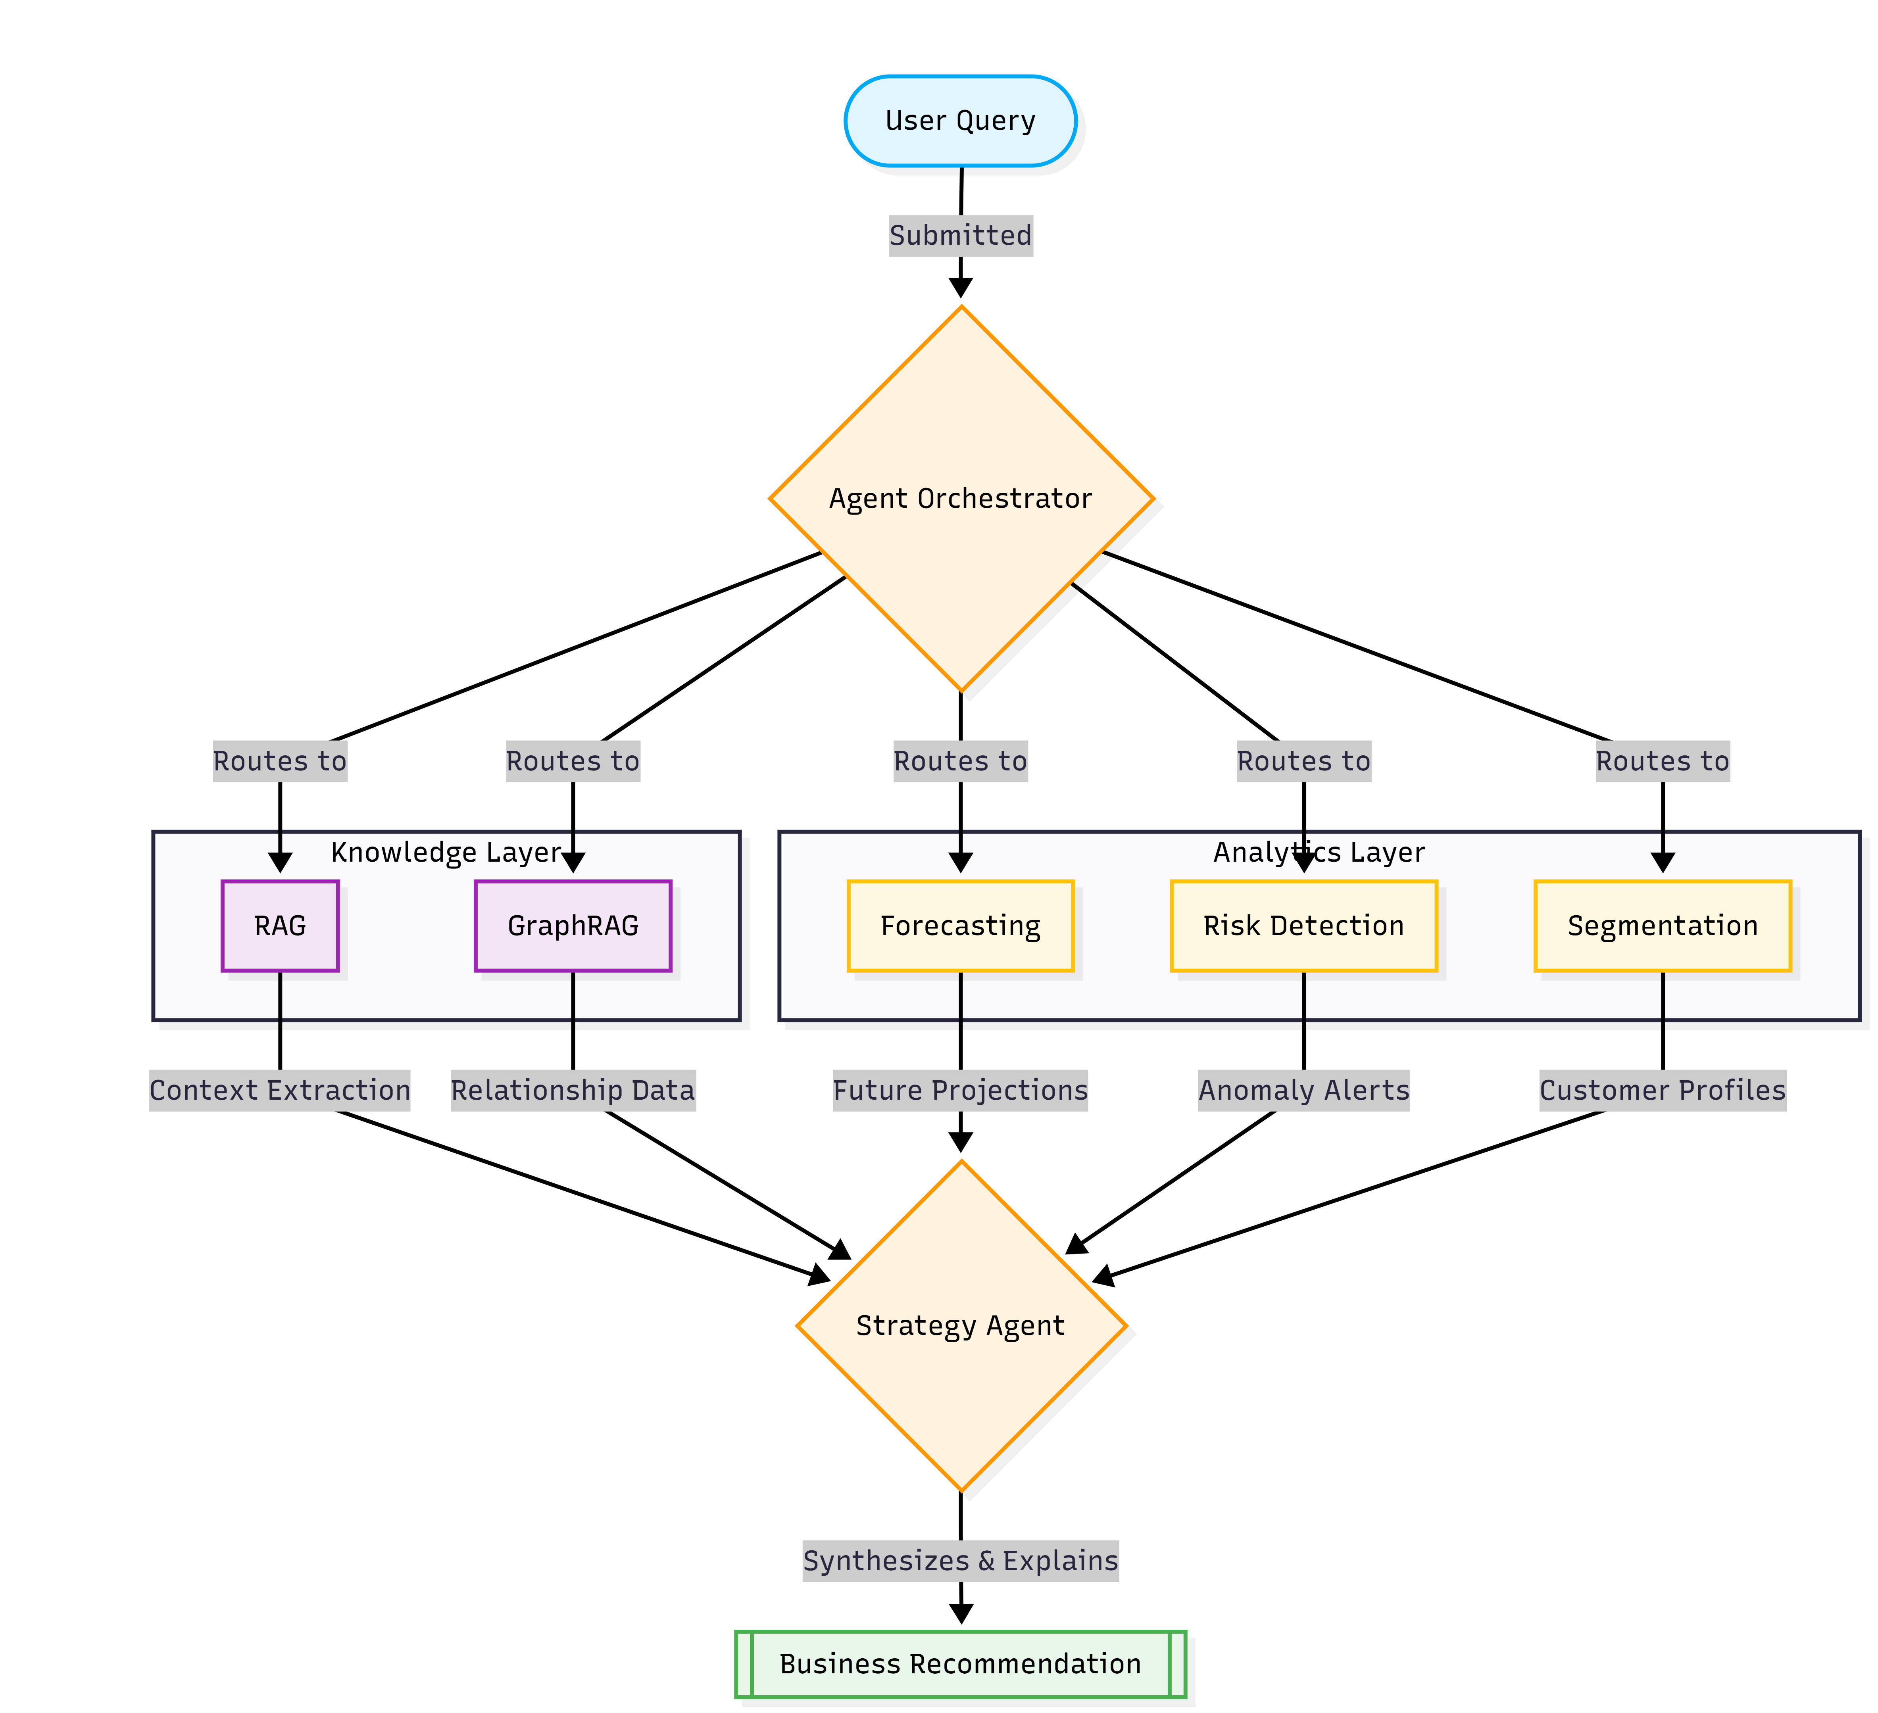
18.2 Machine Learning Layer
Purpose: Provide predictive intelligence using historical business data.
The Machine Learning layer focuses on answering:
- What will happen?
- What risks exist?
- Which customers require attention?
18.3 Forecasting System
Business Objective: Predict future business performance.
Predicted metrics include: Revenue, Expenses, Profit, Cash Flow.
Business Questions:
- What will next quarter's revenue be?
- Is business growth slowing down?
- How will profitability change over time?
Input Features:
- Financial Features: Revenue, Expenses, Profit, Cash Flow.
- Transaction Features: Transaction Volume, Average Transaction Value, Growth Rates.
- Time Features: Month, Quarter, Year, Seasonal Indicators.
Forecasting Models:
- Prophet: Used as a baseline forecasting model. Handles seasonality, trends, and interpretable results.
- XGBoost: Used for structured business forecasting. High performance, feature importance analysis, excellent tabular data support.
- LightGBM: Used as a high-speed alternative. Fast training, low memory usage, strong predictive performance.
Forecasting Workflow:
Historical Data ➔ Data Cleaning ➔ Feature Engineering ➔ Model Training ➔ Model Evaluation ➔ MLflow Tracking ➔ Prediction Service
Evaluation Metrics:
- MAE: Mean Absolute Error (Measures average prediction error).
- RMSE: Root Mean Square Error (Penalizes large prediction errors).
- MAPE: Mean Absolute Percentage Error (Primary business metric). Target: MAPE < 15%
18.4 Anomaly Detection System
Business Objective: Identify unusual financial activities and operational risks.
Example Scenarios:
- Unexpected expenses
- Abnormal revenue spikes
- Suspicious transactions
- Financial irregularities
Model: Isolation Forest
Chosen because: No labeled anomaly dataset required, Efficient for financial data, Widely adopted in industry.
Workflow:
Transaction Data ➔ Feature Extraction ➔ Isolation Forest ➔ Anomaly Score ➔ Risk Alert
Output:
Each transaction receives: Risk Score, Severity Level, Explanation.
Evaluation Metrics:
Precision, Recall, F1 Score. Target: F1 Score > 0.85
18.5 Customer & Business Segmentation
Objective: Identify meaningful business segments.
Use Cases:
- High-value customers
- At-risk customers
- Revenue concentration analysis
Model:
K-Means Clustering.
Segments: Premium Customers, Regular Customers, At-Risk Customers.
Evaluation:
Silhouette Score. Target: 0.50

19. Retrieval-Augmented Generation (RAG)
Purpose: Enable conversational interaction with enterprise knowledge.
Enterprise Documents Examples:
- Annual Reports
- Financial Statements
- Audit Reports
- Policies
- Operational Documents
Why RAG?
Enterprise information changes frequently. Retraining language models for every document update is impractical. RAG allows knowledge to remain dynamic while maintaining response quality.
RAG Workflow:
Document Upload ➔ Chunking ➔ Embedding Generation ➔ Qdrant Storage ➔ Retriever ➔ Reranker ➔ LLM ➔ Grounded Answer
Chunking Strategy:
- Chunk Size: 500 – 1000 Tokens
- Overlap: 100 – 150 Tokens
Embedding Models: Recommended: BGE Large, Multilingual E5.
Benefits:
- Dynamic knowledge updates
- Source-backed responses
- Reduced hallucinations
- Enterprise search capabilities

20. GraphRAG
Purpose: Enable relationship-aware reasoning.
Traditional RAG retrieves information based on semantic similarity. GraphRAG additionally understands business relationships.
Example Relationship:
Supplier ➔ Supplies ➔ Product ➔ Generates ➔ Revenue ➔ Impacts ➔ Profit
Business Questions:
- Which suppliers impact profitability?
- What caused revenue decline?
- Which operational risks affect performance?
GraphRAG Workflow:
Question ➔ Entity Extraction ➔ Neo4j Search ➔ Relationship Expansion ➔ Context Retrieval ➔ LLM Reasoning ➔ Answer
Advantages:
- Multi-hop reasoning
- Root cause analysis
- Explainable relationships
- Better enterprise intelligence

21. Multi-Agent AI Architecture
Purpose: Complex business questions often require expertise from multiple domains. A single model may not effectively analyze Finance, Risk, Forecasting, and Enterprise Knowledge simultaneously. SynapseOS addresses this through Agentic AI.
Agent Hierarchy:
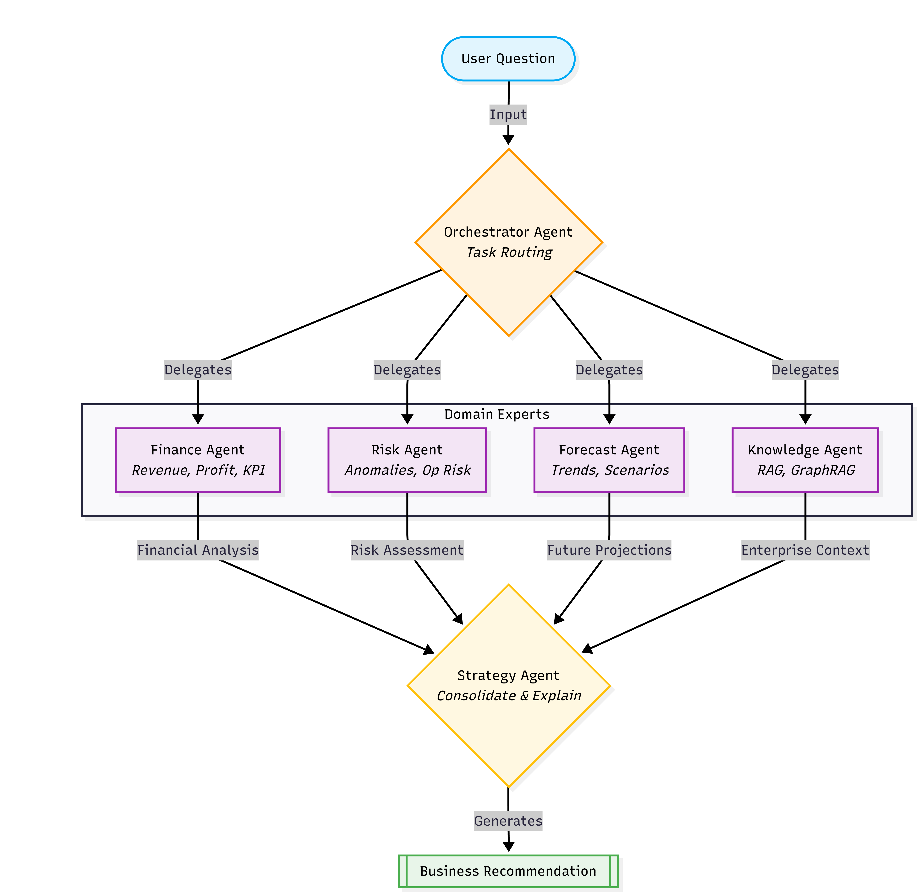

Finance Agent Responsibilities: Revenue Analysis, Profit Analysis, Financial KPI Analysis.
Risk Agent Responsibilities: Risk Detection, Anomaly Investigation, Operational Risk Assessment.
Forecast Agent Responsibilities: Trend Analysis, Future Projections, Scenario Forecasting.
Knowledge Agent Responsibilities: RAG, GraphRAG, Document Intelligence.
Strategy Agent Responsibilities: Consolidate findings, Generate recommendations, Explain decisions.

22. Model Context Protocol (MCP)
Purpose: Provide standardized access to tools and enterprise resources.
MCP Architecture:
Agent ➔ MCP Server ➔ Tool
MCP Servers:
- SQL MCP: Accesses financial data.
- Forecast MCP: Accesses forecasting services.
- RAG MCP: Accesses enterprise documents.
- GraphRAG MCP: Accesses relationship intelligence.
- Simulation MCP: Executes Digital Twin simulations.
Benefits: Tool standardization, Scalability, Extensibility, Separation of concerns.

23. Digital Twin Simulation
Purpose: Support strategic decision-making through simulation.
Business Questions:
- What happens if marketing spending increases?
- What happens if supplier costs increase?
- What happens if operational expenses decrease?
Digital Twin Workflow:
Current Business State ➔ Scenario Input ➔ Forecast Models ➔ Monte Carlo Simulation ➔ Risk Assessment ➔ Business Recommendation
Example Scenario:
- Input: Marketing Budget +20%
- Output: Revenue Increase: +11% | Profit Increase: +6% | Risk Level: Low
- Recommendation: Proceed with investment.
Monte Carlo Simulation:
- Purpose: Estimate possible future outcomes.
- Iterations: 1000+
- Outputs: Best Case, Worst Case, Most Likely Case.

24. AI Evaluation Framework
Evaluation is critical to ensure model reliability and business value.
Forecasting Evaluation
- Metrics: MAE, RMSE, MAPE
- Target: MAPE < 15%
Anomaly Detection Evaluation
- Metrics: Precision, Recall, F1 Score
- Target: F1 > 0.85
RAG Evaluation
- Frameworks: Ragas, DeepEval
- Metrics: Faithfulness, Context Precision, Context Recall, Answer Relevance
- Target: 0.85
GraphRAG Evaluation
- Metrics: Entity Coverage, Relationship Accuracy, Multi-Hop Retrieval Accuracy
- Target: Relationship Accuracy > 90%
Agent Evaluation
- Metrics: Task Completion Rate, Tool Success Rate, Response Quality
- Target: Task Completion Rate > 90%
Digital Twin Evaluation
- Metrics: Simulation Accuracy, Scenario Stability, Recommendation Consistency
- Target: Simulation Accuracy > 85%

25. Expected AI Outcomes
The Intelligence Layer is expected to provide:
- Accurate forecasting
- Risk detection capabilities
- Enterprise knowledge retrieval
- Relationship reasoning
- Explainable recommendations
- Strategic simulation support
Collectively, these capabilities transform SynapseOS from a traditional analytics platform into a comprehensive Enterprise Decision Intelligence System.

26. MLOps Architecture
26.1 Overview
A key limitation of many Machine Learning projects is the absence of a structured model lifecycle. Models are often trained once and deployed without proper monitoring, versioning, or retraining strategies. SynapseOS adopts MLOps principles to ensure that machine learning models remain reproducible, observable, and maintainable.
26.2 MLOps Lifecycle
Data ➔ Feature Engineering ➔ Model Training ➔ Evaluation ➔ MLflow Tracking ➔ Model Registry ➔ Deployment ➔ Monitoring ➔ Retraining
26.3 MLflow Integration
MLflow is used as the central MLOps platform.
- Responsibilities: Experiment Tracking, Model Versioning, Artifact Management, Model Registry.
- Example Experiment: Experiment: Revenue Forecasting | Model: XGBoost | MAPE: 12.1% | Version: v1.0
26.4 Model Registry
Models are promoted through stages:
Development ➔ Staging ➔ Production
- Benefits: Controlled releases, Rollback capability, Reproducibility.
26.5 Model Monitoring
- Forecasting Models: MAPE, RMSE, Prediction Volume.
- Risk Models: Alert Volume, Precision, Recall.
- Agent Performance: Task Completion Rate, Tool Success Rate.
26.6 Future Enhancements
Future versions may incorporate:
- Data Drift Detection
- Concept Drift Detection
- Automated Retraining Pipelines

27. Observability Architecture
27.1 Overview
Observability ensures that system behavior can be understood and diagnosed in production environments. The stack consists of: Logging, Monitoring, Distributed Tracing.
27.2 Logging
Structured logging is implemented across all services.
- Log Categories: Application Logs, Agent Logs, MCP Logs, Security Logs, Prediction Logs.
- Logging Flow: Application ➔ Structured Logs ➔ Loki ➔ Grafana
27.3 Monitoring
Monitoring provides real-time visibility into system health.
- Monitoring Stack: Prometheus (Collects metrics), Grafana (Visualizes metrics).
- System Metrics: * Infrastructure: CPU, Memory, Disk Usage.
  - API: Request Count, Latency, Error Rate.
  - AI: Forecast Requests, Agent Requests, Token Usage.
  - Database: Query Performance, Connection Counts.
- Monitoring Flow: Services ➔ Prometheus ➔ Grafana Dashboards
27.4 Distributed Tracing
OpenTelemetry is used to trace requests across services.
- Example Trace: User ➔ API Gateway ➔ Agent Service ➔ GraphRAG Service ➔ Neo4j ➔ Qdrant ➔ LLM ➔ Response.
- Benefits: Bottleneck identification, Performance optimization, Failure diagnosis.

28. Security & Trust Framework
28.1 Overview
Enterprise adoption depends on trust, security, and explainability. Security is incorporated across all layers of SynapseOS.
28.2 Authentication
JWT-based authentication is implemented.
Login ➔ Credential Validation ➔ JWT Generation ➔ Authorized Access
28.3 Authorization
Role-Based Access Control (RBAC) is implemented.
- Roles: Administrator (Platform management), Analyst (Data analysis and reporting), Executive (Strategic dashboards and simulations).
28.4 Multi-Tenant Isolation
Each organization operates within its own logical environment. Isolation is enforced using tenant_id.
- Benefits: Data separation, Security, Scalability.
28.5 Data Protection
- Encryption in Transit: HTTPS/TLS
- Secure Storage: Encrypted databases and storage.
- Secret Management: Environment variables and container secrets.
28.6 Auditability
The platform maintains audit records for: Logins, Uploads, Forecast Requests, Simulations, Agent Actions.
28.7 Explainability
AI outputs are designed to be explainable.
- Forecasting: Confidence intervals.
- RAG: Source citations.
- GraphRAG: Relationship paths.
- Agents: Reasoning traces.

29. Business Model
29.1 Overview
SynapseOS follows a Software-as-a-Service (SaaS) business model.
29.2 Free Tier
- Target Users: Students, Researchers, Startups.
- Features: Limited forecasting, Limited document uploads, Basic analytics.
- Purpose: User acquisition and product awareness.
29.3 Professional Plan
- Target Users: SMEs, Consulting Firms.
- Features: Advanced forecasting, RAG, GraphRAG, Multi-Agent Analysis, Digital Twin Simulations.
29.4 Enterprise Plan
- Target Users: Mid-sized Enterprises, Large Organizations.
- Features: Unlimited users, Custom integrations, Dedicated deployment, Enterprise support.
29.5 Future Revenue Opportunities
- Consulting Services (AI transformation consulting).
- Industry Editions (Retail, Manufacturing, Financial Intelligence).
- Enterprise Integrations (ERP and CRM).
30. Project Timeline
- Week 1: Platform Foundation & Machine Learning
  - Deliverables: Authentication, Multi-Tenant SaaS, Forecasting, Risk Detection, Dashboard.
- Week 2: Knowledge Intelligence
  - Deliverables: RAG, GraphRAG, Neo4j, Qdrant, MCP Foundation.
- Week 3: Agentic AI & Digital Twin
  - Deliverables: Multi-Agent System, Strategy Agent, Digital Twin, Monte Carlo Simulation.
- Week 4: Production Engineering
  - Deliverables: MLflow, Logging, Monitoring, Tracing, Real-Time Processing, Docker Deployment.

31. Expected Outcomes
Upon successful completion, SynapseOS will demonstrate competencies across multiple domains:
- Data Science: Forecasting, Statistical Modeling, Simulation.
- Machine Learning: Model Development, Evaluation, Serving.
- Artificial Intelligence: Agentic AI, MCP, Decision Intelligence.
- Generative AI: RAG, GraphRAG, Enterprise Search.
- MLOps: Experiment Tracking, Model Lifecycle Management.
- Software Engineering: FastAPI Microservices, Containerization, Production Architecture.

32. Future Scope
Potential future enhancements include:
- Real-Time Digital Twin: Continuous business simulation.
- Advanced Agent Collaboration: Autonomous decision workflows.
- Multi-Modal Intelligence: Integration of text, images, and documents.
- Cloud-Native Deployment: Kubernetes and multi-region infrastructure.
- Advanced MLOps: Automated retraining and drift detection.

33. Conclusion
SynapseOS presents a comprehensive approach to Enterprise Financial Intelligence by integrating Machine Learning, Generative AI, Agentic AI, GraphRAG, MCP, and Digital Twin Simulation within a unified architecture.
The platform moves beyond traditional analytics by enabling organizations to understand historical performance, predict future outcomes, retrieve enterprise knowledge, analyze business relationships, and evaluate strategic decisions before implementation.
By combining predictive intelligence, knowledge intelligence, relationship intelligence, and decision intelligence, SynapseOS demonstrates how modern AI systems can transform enterprise decision-making processes.
The project serves as a practical demonstration of production-oriented Data Science, Machine Learning Engineering, AI Engineering, GenAI Engineering, and MLOps practices within a single integrated platform.

References
- FastAPI Documentation
- LangGraph Documentation
- MLflow Documentation
- Neo4j Documentation
- Qdrant Documentation
- Prophet Documentation
- XGBoost Documentation
- LightGBM Documentation
- OpenTelemetry Documentation
- Prometheus & Grafana Documentation

